I have friends in many parts of the world interested and / or doing various forms of green building. I share my "bahareque," or "wattle and daub" experience with some photos and brief writings, as we did with the super adobe construction. The first three rooms are already finished.
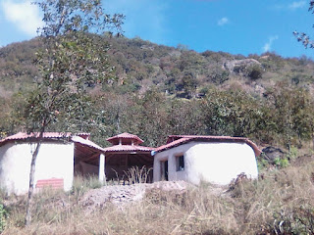
The super adobe is free material but it is very intense work. For this reason, we are going to make the bathroom, which is an external corner between two hexagons, with a wall of bahareque, a traditional Mexican method that uses a structure of reed filled with mud or "cob." Bahareque is very similar to the technical "wattle and daub" of medieval England.
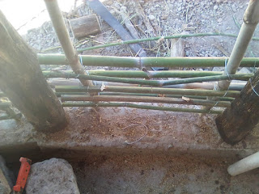

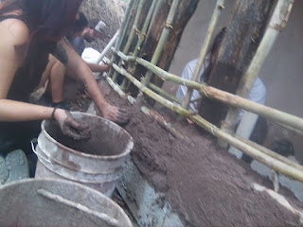
I cut more oaks from the mountain for the firm wall structure. They are anchored to a conventional concrete, gravel and rebar foundation. Between the firm oak beams we put a reed structure, which we also cut on our land. Then we are going to fill the reed structure with cob, a mixture of mud, sand, and straw.
I saw some videos on wattle and daub and a few examples in the houses nearby. They usually use mud. I decided to use cob, adding straw to the mud with sand. It has better consistency and you can add larger balls without breaking them. Therefore, it is not only faster with cob but also stronger.
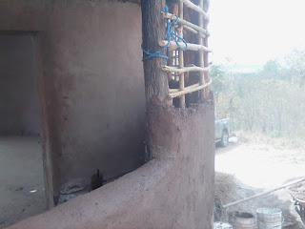
You can see in the photo of the window how the cob is very smooth and does not really need a top coat inside the house. On the outside we will put a very thin layer with the same mixture of mud and sand, only with a little lime. The lime makes that the wall does not fall apart if it is stuck by the rain. The dry parts of the wall reveal the final color, whiter than earth without lime. In our mountain there is brown, red, yellow and purple mud and it could vary and / or mix these colors but I like the beige of the earth bleached with lime.

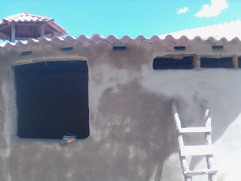

All Essays And Books

